“Mathematical Modelling for Stock Price Prediction and Portfolio Optimisation Using UK Daily Historical Stock Market Data (1988-2024)”

Student’s Name

Date

**Table of Contents**

1. Introduction 3

1.1 Overview and Purpose of the Project 3

1.2 Research Question, Aim and Objectives 4

1.2.1 Research Question 4

1.2.2 Aim 4

1.2.3 Objectives 4

2. Background 4

2.1 Introduction to Stock Price Prediction 4

2.2 Selection Criteria for Papers 5

2.3 Critical Analysis of Key Papers 6

2.3.1 Paper 1: "Deep Learning for Stock Price Prediction and Portfolio Optimisation". 6

2.3.2 Paper 2: "Portfolio Optimisation-Based Stock Prediction Using Long-Short Term Memory Network in Quantitative Trading". 7

2.3.3 Paper 3: “Predicting Economic Trends and Stock Market Prices with Deep Learning and Advanced Machine Learning Techniques”. 8

2.3.4 Paper 4: “Predicting stock investments based on sentiment and historical price data”. 9

2.4 Summary of Literature Review 10

References 11

# 1. Introduction

## 1.1 Overview and Purpose of the Project

The mathematical modelling techniques applied to the project related to stock price prediction and portfolio optimisation, using daily historical stock market data of the UK between 1988 and 2024. The importance of this research involves providing investment strategies that use quantitative analysis to leverage investment strategies that are helpful in the stock market (Kostadinova *et al.*, 2021). As these are inherently volatile financial markets where multiple aspects affect the prices of stocks, accurately predicting stock prices can give a market advantage enable to make suffic andformed decisions.

Finance is incomplete without the use of mathematic models, which are used as the tools for structured analysis of historical data and prediction of future trends. The most used model is the Geometric Brownian Motion (GBM) (Masuda, 2024). It modelled stock prices as a Cantor continuous stochastic process with a temporal variable with a temporal variable composed of constant change in time attributed to both deterministic trends and random fluctuations. Moreover, this model applies to the simulation of asset price movements with time, an essential component in the option pricing and risk management strategy. While GBM forms an impenetrable framework for long-term predictions, it also has significant shortcomings, such as constant volatility and normally distributed returns, which it does not always hold (Kostadinova *et al.*, 2021).

The mathematical models are explored further by applying them to accurate world data from the UK stock market. The research attempts to identify patterns by analysing daily stock prices and returns from indices such as the FTSE 100 to identify investment strategies. The FTSE 100 index, which consists of the 100 largest companies listed on the London Stock Exchange, is an important gauge of how these companies have performed over the decades. Understanding how this index has evolved since 1984 gives valuable context to evaluate historical trends and correctly predict future price movements. Stock price prediction is a significant project focus besides portfolio optimisation (Abdi *et al.*, 2024). Portfolio optimisation is choosing a mix of assets to maximise returns while minimising risk. Still, this decision has to be considered with many factors, including the tolerance to your risk, how long you are looking to invest and the current market conditions. Also commonly employed to get the optimal asset allocation are techniques like Modern Portfolio Theory (MPT) and Black Litterman Model. These methods are expected returns mixed with investor perspective and market equilibrium, making for a more specific approach to portfolio management (Pérez, 2021).

Incorporating mathematical modelling in portfolio optimisation facilitates decision making, and facilitates decision-making, and helps in risk assessment. To evaluate potential investments better, investors can use quantitative techniques to help them understand the tradeoffs between risk and return. The data used in this project will be historical data for various portfolio configurations, and multiple market scenarios will be simulated to assess their performance. It aims to develop insights that investors can apply to their more effective strategies given an ever-changing financial landscape using the UK's daily historical stock market data from 1988 to 2024.

## 1.2 Research Question, Aim and Objectives

### 1.2.1 Research Question

* How does one enable the mathematical modelling techniques to forecast stock values and optimise portfolios using the daily historical stock market from the UK from 1988 to 2024?

### 1.2.2 Aim

The study aims to analyse the mathematical modelling for stock price prediction and portfolio optimisation using the UK's daily historical stock market data.

### 1.2.3 Objectives

* Collect British historical stock market data and clean it.
* Apply machine learning and statistical tools to predict stock returns.
* Compare the performance of several predictive models.
* Develop a rationalized portfolio plan based on expected returns and risk control concepts.
* Back test how well the recommended plan works through back testing methods.

# 2. Background

## 2.1 Introduction to Stock Price Prediction

Investment assets are defined as a compilation of assets organised into a portfolio. The investment decision-making process, using a regulated tactical investment strategy aligned with the investment time horizon to optimise return on investment, is termed the portfolio management process. An investment portfolio may be handled by two conventional methods and one quantitative approach (Olawale, Iworiso and Amaunam, 2023). Both methodologies exhibit similar traits in examining a limited array of pivotal determinants of equity prices, analysing historical data to estimate these critical drivers, establishing eligibility criteria for stock selection, and evaluating performance over time. Nonetheless, conventional portfolio management mainly relies on in-depth study, regime transitions, essential traits, and qualitative elements. Conversely, quantitative portfolio management relies on universe research, discipline, verification, risk management, and minimal costs. Moreover, it may enhance its ability to identify additional possibilities while effectively managing dangers it should avoid (Ta, Liu and Tadesse, 2020).

Quantitative trading pertains to tactics, including quantitative investment analysis, whereby mathematical models are used to develop an automated trading system. Portfolio creation in quantitative trading involves selecting and investing in several equities to mitigate risk. Every quantitative trading strategy is founded on market trends, trade entry and exit points, price history, and volume. The primary element of the quantitative method for constructing an effective portfolio is formulating an accurate forecasting model (Sebastian and Tantia, 2024). In quantitative trading, stock prediction is crucial for forecasting market trends, whether broadly or for specific equities. Predicting stock prices is seen as the most formidable challenge in financial and time series analysis owing to the intricacies of multivariate time series attributes and the vast quantities of financial data involved. Numerous statistical and machine learning methodologies have been devised to enhance predictive accuracy (Thio-Ac *et al.,* 2023).

## 2.2 Selection Criteria for Papers

There are several key factors to include in the selection criteria for academic papers to guarantee quality and relevance. The study must be in line with the journal's scope and focus, and it has to be an original research contribution towards the current issues of the field. Secondly, the writing is examined methodologically in terms of rigour and clarity, and the research is shown to be based on ethical research standards and presented in a structured way. The findings are finally evaluated for their importance and possible influence on the discipline, as well as the study's contribution in general to increasing knowledge in the academic community.

## 2.3 Critical Analysis of Key Papers

### 2.3.1 Paper 1: “Deep Learning for Stock Price Prediction and Portfolio Optimisation”.

Sebastian and Tantia (2024) explore the use of deep learning methodological approaches, namely stacked Long Short-Term Memory (LSTM) networks, to predict stock prices as well as improve portfolio optimization strategies. The study is bifurcated into two major stages. They use a Stacked LSTM model to predict the returns of NIFTY stocks, and then they rank the said stocks according to the predicted returns. Subsequently, 30 different portfolios are built using the top 7, 8, 9, and 10 NIFTY stocks with different objectives, and risk and return comparisons are made on the basis of risk and return metrics. One strength of this study is that it focuses on the stock market dynamics of developing countries, which are usually known to be less stable than their developed counterparts. According to Sebastian and Tantia (2024), this means that the optimal return comes from a portfolio of five stocks, but complexity and excess diversification occur with more than nine stocks. This insight reinforces the capability of learning from historical and prospective aspects of assets in their two-stage portfolio optimization approach. However, this study is limited to NIFTY stocks and hence restricts the generalisability of the results across all markets and asset classes. In addition, training deep learning models is not extensively dealt with in terms of computational intensity, which might be a practical challenge for real-time applications (Sebastian and Tantia, 2024).

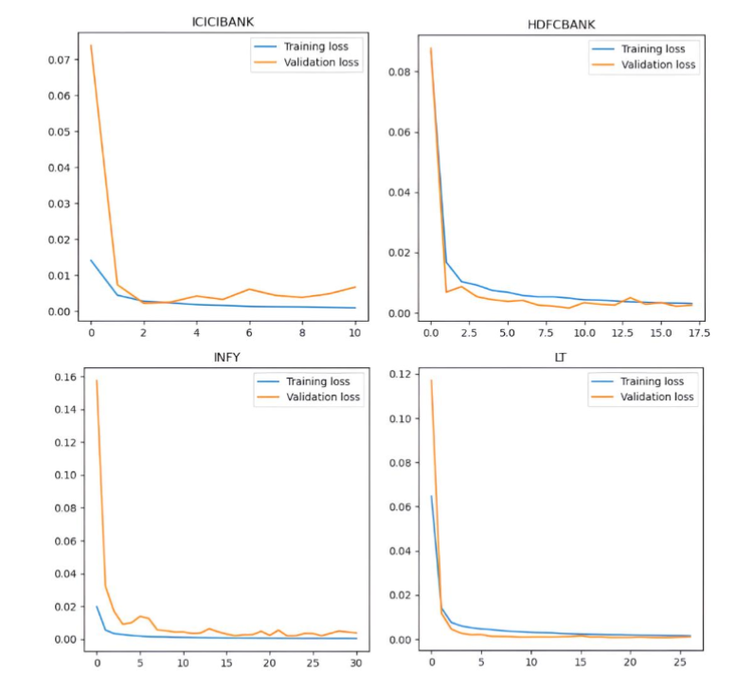

Figure 1: Learning Curves

### 2.3.2 Paper 2: “Portfolio Optimisation-Based Stock Prediction Using Long-Short Term Memory Network in Quantitative Trading”.

Ta, Liu, and Tadesse (2020), the application of Long Short-Term Memory (LSTM) networks is used when quantitative trading stock prediction and portfolio optimisation. They study the integration of an LSTM-based predictive model with the portfolio optimisation techniques to incorporate with the trading strategies. One thing that makes this study really solid is that it integrates very advanced machine learning models with more traditional portfolio optimisation techniques to provide a somewhat holistic view of quantitative trading. Ta, Liu, and Tadesse (2020) prove that LSTM networks allow one to capture the temporal dependencies of stock price data effectively. Nevertheless, the use of historical price data in the study may prevent it from taking into consideration unforeseen events in the market or structural changes in the market. Additionally, the effects of transaction costs and market liquidity are not thoroughly researched in the research, which is necessary for the deployment of the proposed strategies.

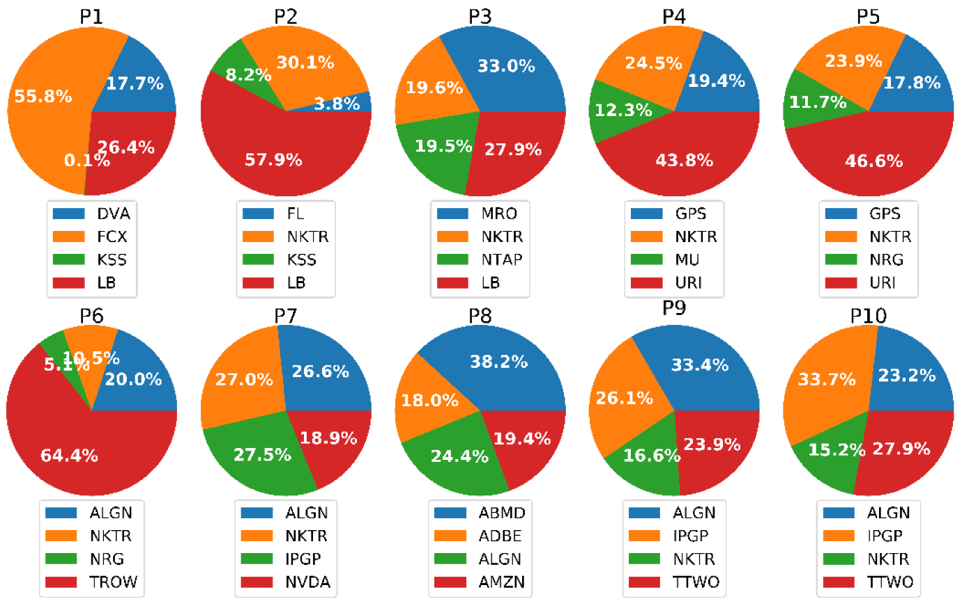

Figure 2: LSTM Optical Allocation for Each Portfolio

### 2.3.3 Paper 3: “Predicting Economic Trends and Stock Market Prices with Deep Learning and Advanced Machine Learning Techniques”.

In Chang *et al.* (2024), the emphasis is drawn on the usage of deep learning, as well as advanced machine learning approaches for predicting economic trends and stock market prices. The outputs from their work have been studied using multiple models, including neural networks and ensemble learning methods, to analyse complex financial data. Perhaps the most important strength of this research is that it used multiple economic indicators and market variables in its research, which makes the predictive models much more robust. Empirical evidence is given by the authors that advanced machine learning methods can predict economic and market trends better than traditional statistical methods. Despite this, the study will be complicated for those without a sound understanding of machine learning. Furthermore, some deep learning models are black boxes, so it is hard to interpret the rationale behind certain predictions for investors. The last issue the study does not sufficiently address is the possible overfitting that may arise from complex models, thereby affecting the validity of predictions in real-world applications (Chang *et al.*, 2024).

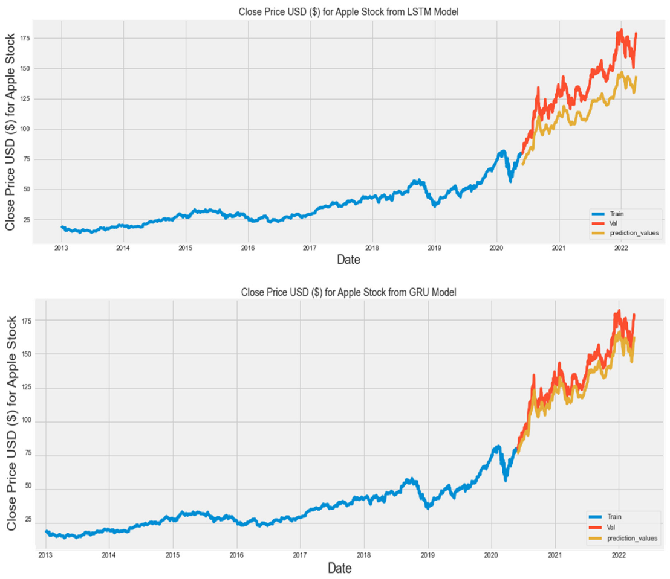

Figure 3: Actual and Predicted price of Apple stocks

### 2.3.4 Paper 4: “Predicting stock investments based on sentiment and historical price data”.

Olawale, Iworiso, and Amaunam (2023) apply sentiment analysis to historical price data to predict stock investments. In their study, they apply natural language processing techniques that analyse sentiment coming from different sources, e.g. news articles and social media, and combine it with the historical data of price to enhance the prediction accuracy. An important contribution of this research is to generate an innovative way to incorporate qualitative sentiment data to obtain a more complete picture of the factors influencing stock prices. The authors show how sentiment analysis as a powerful extrinsic data point can throw new light on quantitative data and help inform better investment decisions. However, there are difficulties associated with the accuracy and reliability of the sentiment of the study that, according to the natural language processing techniques, it may not accurately understand the context or sarcasm in the textual information. Also, reliance on publicly available sentiment data may lead to biases, and the study does not give much thought to the degree to which such biases may affect performance. In addition, the study does not spend much time on the weighting to be applied to the qualitative sentiment data in comparison with the quantitative price data (Olawale, Iworiso and Amaunam, 2023).

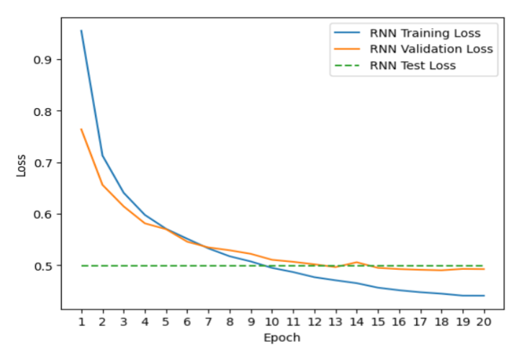

Figure 4: RNN Model Loss Plot

## 2.4 Summary of Literature Review

The literature on stock price prediction and portfolio optimisation has shown that the dependency on high mathematical and computational models to get better investment strategies is growing day by day. A variety of studies have tackled this problem through different approaches such as deep learning, machine learning and sentiment analysis to achieve better forecasting accuracy and improve the allocation of the asset. According to Sebastian and Tantia (2024), deep learning, especially stacked LSTMs, is valuable in the prediction of stock returns and generating optimised portfolios. The results of their study reflect the tradeoffs established from diversification and complexity in portfolio management. Ta, Liu, and Tadesse (2020) couple LSTM networks with portfolio optimisation procedures to trace the temporal dependence in stock prices.

Chang et al. (2024) broaden the scope by also incorporating other economic indicators into machine learning models, and that model incorporates both neural networks and ensemble techniques that perform traditional statistical methods. These models are, however, too complex to be interpretable. On the other hand, Olawale, Iworiso, and Amaunam (2023) consider sentiment analysis as an adjunct tool that has drawn on both quantitative and qualitative data collection to enhance forecasting. This approach brings about a holistic vision of the market dynamics, but on the other part, it is deceived in interpreting the sentiment accurately. The literature supports the need to couple the mathematical model with financial data, as well as model complexity, data reliability and real-world applicability.

# References

Abdi, F., Abolmakarem, S., Yazdi, A.K., Tan, Y. and Choque, I.A.M. (2024) ‘Prospective Portfolio Optimization With Asset Preselection Using a Combination of Long and Short Term Memory and Sharpe Ratio Maximization’, *IEEE Access* [Preprint]. Available at: <https://ieeexplore.ieee.org/abstract/document/10689666/> (Accessed: 24 February 2025).

Chang, V., Xu, Q.A., Chidozie, A. and Wang, H. (2024) ‘Predicting Economic Trends and Stock Market Prices with Deep Learning and Advanced Machine Learning Techniques’, *Electronics*, 13(17), p. 3396. Available at: <https://doi.org/10.3390/electronics13173396>.

Kostadinova, V., Georgiev, I., Mihova, V. and Pavlov, V. (2021) ‘An application of Markov chains in stock price prediction and risk portfolio optimization’, in *AIP Conference Proceedings*. AIP Publishing. Available at: <https://pubs.aip.org/aip/acp/article-abstract/2321/1/030018/729773> (Accessed: 24 February 2025).

Masuda, J.S. (2024) *Portfolio Optimization Using a Hybrid Machine Learning Stock Selection Model*. PhD Thesis. Massachusetts Institute of Technology. Available at: <https://dspace.mit.edu/handle/1721.1/157186> (Accessed: 24 February 2025).

Mihova, V., Georgiev, I., Raeva, E., Georgiev, S. and Pavlov, V. (2023) ‘Validation of stock price prediction models in the conditions of financial crisis’, *Mathematics*, 12(1), p. 33.

Olawale, I.O., Iworiso, J. and Amaunam, I. (2023) ‘Predicting stock investments based on sentiment and historical price data’, *International Journal of Data Envelopment Analysis and Operations Research*, 4(1), pp. 1–32. Available at: <https://repository.londonmet.ac.uk/8809/1/ijdeaor-4-1-1.pdf>

Pérez, G.A. (2021) ‘Forecasting and optimization of stock trades’, *University of Seville* [Preprint]. Available at: <https://core.ac.uk/download/pdf/477928755.pdf> (Accessed: 24 February 2025).

Sebastian, A. and Tantia, V. (2024) ‘Deep Learning for Stock Price Prediction and Portfolio Optimization.’, *International Journal of Advanced Computer Science & Applications*, 15(9). Available at: <https://www.researchgate.net/profile/Ashy-Sebastian/publication/384707455_Deep_Learning_for_Stock_Price_Prediction_and_Portfolio_Optimization/links/670921f468e0f20a610ca784/Deep-Learning-for-Stock-Price-Prediction-and-Portfolio-Optimization.pdf> (Accessed: 24 February 2025).

Ta, V.-D., Liu, C.-M. and Tadesse, D.A. (2020) ‘Portfolio Optimization-Based Stock Prediction Using Long-Short Term Memory Network in Quantitative Trading’, *Applied Sciences*, 10(2), p. 437. Available at: <https://doi.org/10.3390/app10020437>.

Thio-Ac, A.C., Cabrales, D.D., Calibara, D.E., Madrazo, M.V., Matawaran, A.C.C., Micaller, G.E., Fernandez, E.O., Amado, T.M., Jorda, R.L. and Tolentino, L.K.S. (2023) ‘Stock Price Prediction and Portfolio Optimization Using Hidden Markov Model and Quadratic Programming’, in *2023 International Conference on Integrated Intelligence and Communication Systems (ICIICS)*. IEEE, pp. 1–7. Available at: <https://ieeexplore.ieee.org/abstract/document/10421179/> (Accessed: 24 February 2025).